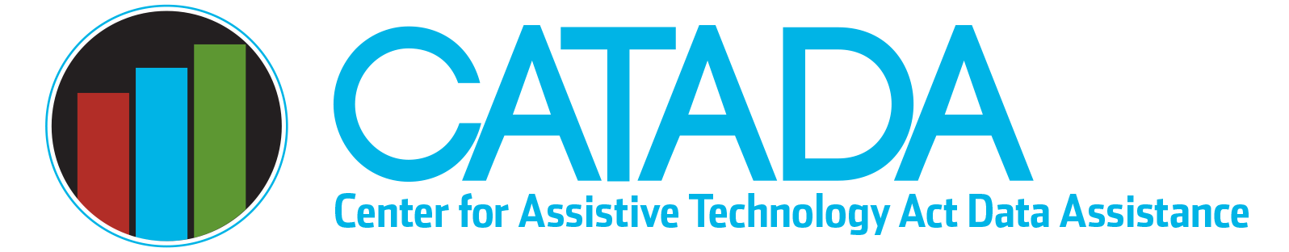

Short-term versus Open-ended Loans

The following information is provided to support the determination of a “device loan” event being reported as either a short-term device loan or an open-ended device loan in the AT Annual Progress Report (APR).
Any request to borrow AT first needs to have a clearly identified purpose. The ability of program staff to accurately identify the purpose of a request to borrow AT is fundamental to APR data reporting with fidelity, specifically determining if the event is a short-term loan or open-ended loan and which performance measure (access or acquisition) must be collected.

Decision-making purpose — short-term loan with access performance measure collected

Device loans for decision-making purposes (which should be the majority) typically have a relatively short, fixed loan period pre-determined by the program (e.g., 14 to 35 days). This fixed time period is long enough to allow device trial and data gathering in the natural environment to make an informed decision and short enough to ensure devices that are in high demand return quickly to the device loan inventory to meet borrower requests. Access to a device loan avoids the borrower having to rent the device in order to make a decision (or go without a trial at all) and does not substitute for having to purchase the device.
Individual loan periods may need to be extended for unique situations, but the period fixed by policy is not changed. These extensions would never be interpreted to be for “as long as the individual needed the AT to meet their personal needs” because the loan purpose is for decision-making. The loan program should have established policies that govern length of loan and describe when/how extensions to the loan period will be granted.

Professional development purpose — short-term loan with acquisition performance measure collected

Device loans made to support delivery of training or to conduct professional development activities will be short-term loans. As with loans for a decision-making purpose, the loan program should have established policies that govern how long devices are loaned for this purpose, which could be relatively short depending on the training need (e.g., one class presentation), and should address if/how extensions for the borrowing time will be made. Loans for this purpose are not typically extended in order to ensure inventory is available to be able to respond to consumer requests and avoid waiting lists for high-demand items. Similar to a decision-making purpose, device loans for professional development are not in lieu of the borrower buying the device but in lieu of the borrower renting the device.

Accommodation or loaner purpose with known clear time needed — short-term loan with acquisition performance measure collected

Requests to borrow AT to meet a short-term accommodation need or to use as a loaner while a device is being repaired or while waiting for funding for a permanent device need to be carefully reviewed to determine if this is a known short-term need or not. If the purpose is a short-term accommodation, there should be a clearly known time period (e.g., the AT device is needed for a meeting that lasts three days or a device is needed for a specific week when an individual is visiting family out-of-state). If the purpose is to use as a loaner, there should be a clearly known time period for the repair to be completed or when the funding will be available and the individual will obtain their own device. These loans can be thought of as in lieu of the borrower renting the device rather than buying the device.

Accommodation or loaner purpose without known clear time period needed — open-ended loan with acquisition performance measure collected

If there is no identified short-term time period for which the device is needed, it should be viewed as an open-ended loan and, if possible, be made available for as long as the individual needs it. Being able to place a device on open-ended loan will likely be contingent on device availability within your inventory and demands for that device for other purposes, such as demonstration. Providing a device as a short-term loan and expecting it to be returned at a prescribed date even though the individual continues to need that device presents an ethical dilemma.
For example, it is almost impossible to know the length of time someone discharged from acute care will need AT devices for rehabilitation at home. Devices loaned in this situation are best done as an open-ended loan because the individual should be able to keep those devices for as long as they need them, which could be just a week or two or could be many months, a year, or longer. When AT program staff cannot easily identify the time period that a device will be needed for an accommodation or while waiting for funding/repair, then it should be done as an open-ended loan.
If the AT program cannot support an open-ended loan for the particular device, assistance should be provided to the consumer in identifying other resources for acquiring the device, including rental, purchase, or referral to other sources for used devices.

Caution — Length of loan period alone is not a clear determination

It is important to remember that the length of time the device is loaned is not a clear distinguishing factor in determining if it is a short-term loan or open-ended loan. While short-term loans tend to be made for fewer days than open-ended loans, just because a device is loaned for 30 days or less does NOT mean it is exclusively a short-term loan. Similarly, just because a device is loaned for 90 days (e.g., as a result of extensions to the original loan period), it does NOT mean it is automatically reported as an open-ended loan. The exception is when a device is loaned for a very long period (e.g., 6 months or longer), it is not likely to meet any of the criteria to be a short-term loan.

Caution — Device status (new or not) is not a clear determination

It is also important to note that devices obtained new and those obtained “previously owned” can be used to make both short-term and open-ended loans. The device status is not a clear distinguishing factor in determining if it is a short-term loan or open-ended loan.
The following are common issues of confusion related to APR data reporting. Specific review procedures and items to look for (in the form of red flags) are provided to help identify issues that may be undermining data fidelity. Many of these red flags are built into the National Assistive Technology Act Data System (NATADS) in both the aggregate portion used by all Section 4 AT Act grantees to report their APR and the day-to-day portion that a number of grantees have opted to use as their internal ongoing data management system.
Last updated January 2023

